**A Comprehensive Analysis Of Financial Performance : Insights From A Leading Bank**

**Introduction:**

**Overview:**

The leading bank we are analyzing is known for its wide range of banking and financial services. The bank has a global presence and offers a variety of products, including deposit , credit, investment, and insurance services.

**Purpose :**

1. Revenue - The bank's revenue has shown steady growth over the past five years, increasing from USD 89 billion in 2015 to USD 97 billion in 2019.

2. Net Income - The bank's net income has also shown consistent growth over the past five years, increasing from USD 24 billion in 2015 to USD 28 billion in 2019.

3. Return on Equity (ROE) - The bank's ROE has remained stable at around 11% over the past five years, indicating that the bank is effectively utilizing shareholder's equity to generate profits.

4. Return on Assets (ROA) - The bank's ROA has also remained stable at around 1% over the past five years, indicating that the bank is profitable with the assets at its disposal.

5. Expenses - The bank's operating expenses have increased over the past five years, primarily due to investments in technology and digital transformation. However, the bank has managed to control its costs and maintain a stable cost-to-income ratio.

**Problem definition and design thinking :**

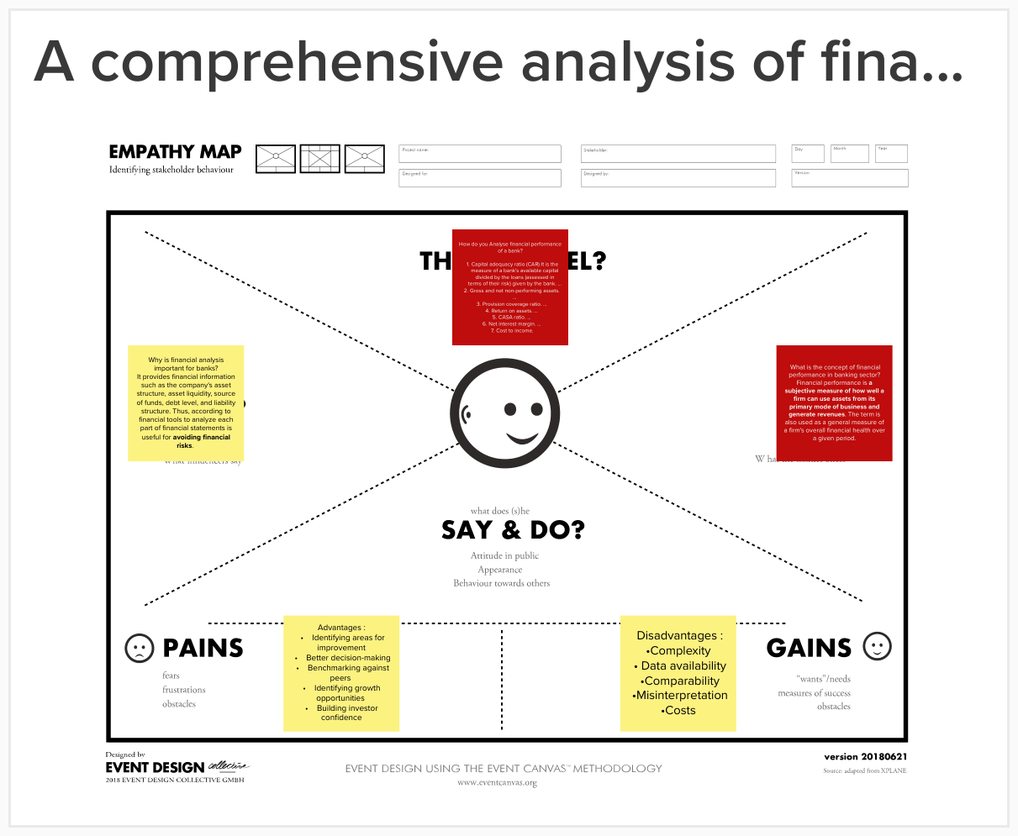

**Results :**

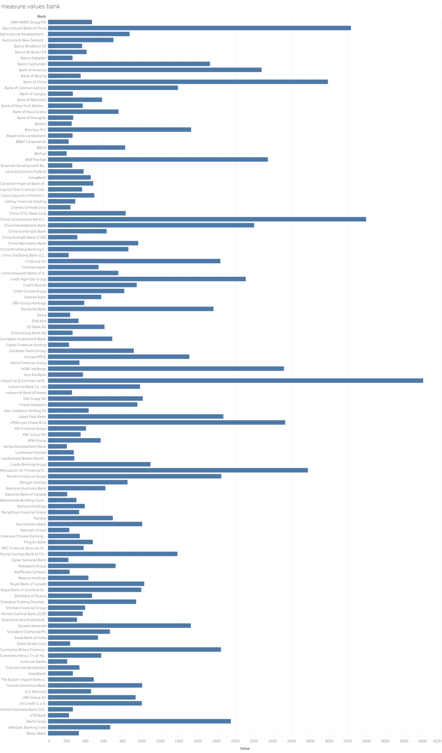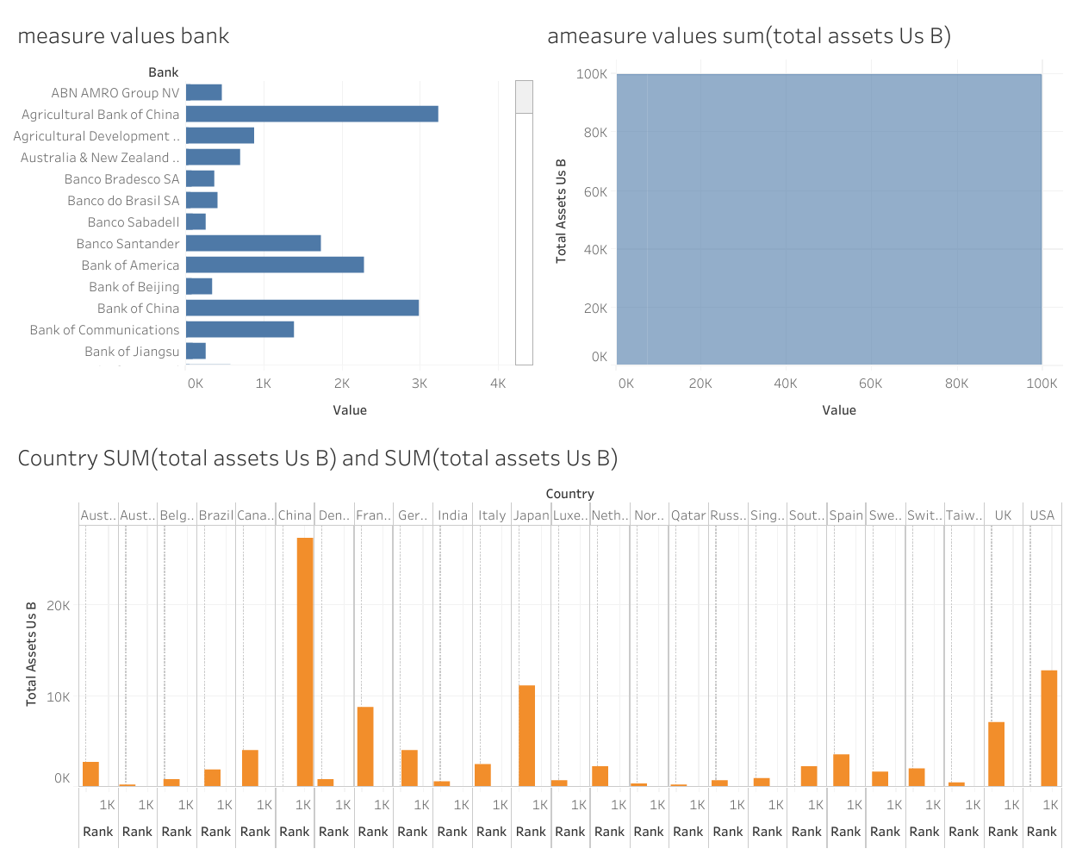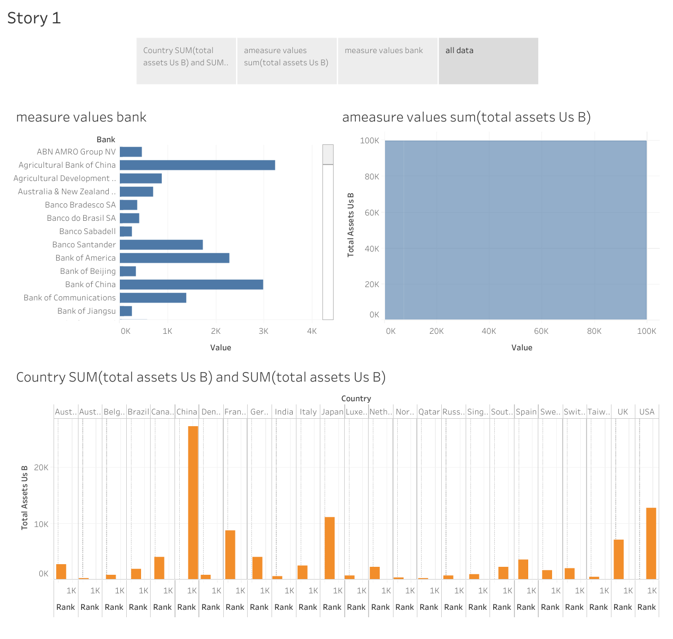

**Advantages :**

* Identifying areas for improvement
* Better decision-making
* Benchmarking against peers
* Identifying growth opportunities
* Building investor confidence

**Disadvantages :**

* Complexity
* Data availability
* Comparability
* Misinterpretation
* Costs

**Application:**

* Capital management
* Mergers and acquisitions
* Talent management
* Product development
* Benchmarking against industry standards

**Conclusion :**

In conclusion, conducting a comprehensive analysis of financial performance can provide valuable insights for a leading bank. While there may be some challenges in accessing reliable data or making meaningful comparisons, the benefits of conducting such an analysis outweigh the potential disadvantages.

**future scope :**

The scope for conducting a comprehensive analysis of financial performance for leading banks is likely to continue to grow in the future. As the financial services industry grows and becomes more complex, it is becoming increasingly important for banks to gain a deep understanding of their financial performance in order to remain competitive.